252. Creating a Cluster with Google Cloud

In google cloud, create cluster in Kubernetes Engine

Name: multi-cluster

Location Type: Zonal, select zone or keep it by default

Master version-default

Node pools

default-pool

No. of nodes-3 is default, if want to change, can do the same.

Machine Type-1vCPU with 3.75GB memory

Advanced Edit --->Create instance and cluster will be created.

253. Don't Forget to Cleanup!

Remember, as long as this cluster is running you will be billed real life money!

If you need to stop the course for any reason remember to shut down this cluster. Directions for cleaning up the Google Cloud cluster can be found in a lecture at the very end of this course. Here's a direct link to it: https://www.udemy.com/docker-and-kubernetes-the-complete-guide/learn/v4/t/lecture/11684242?start=0

254. Kubernetes Dashboard on Google Coud

Go through cluster, and other options of Workloads, Services, Configuration, Storage

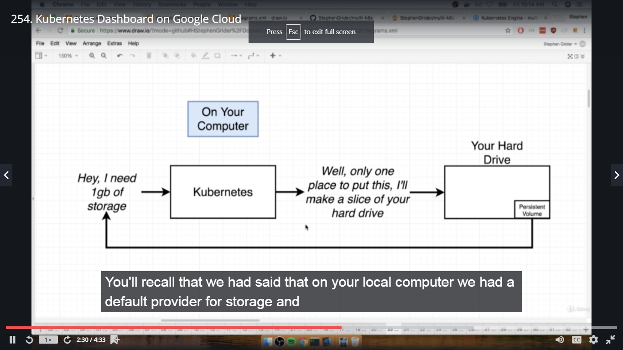

255. Travis Deployment Overview

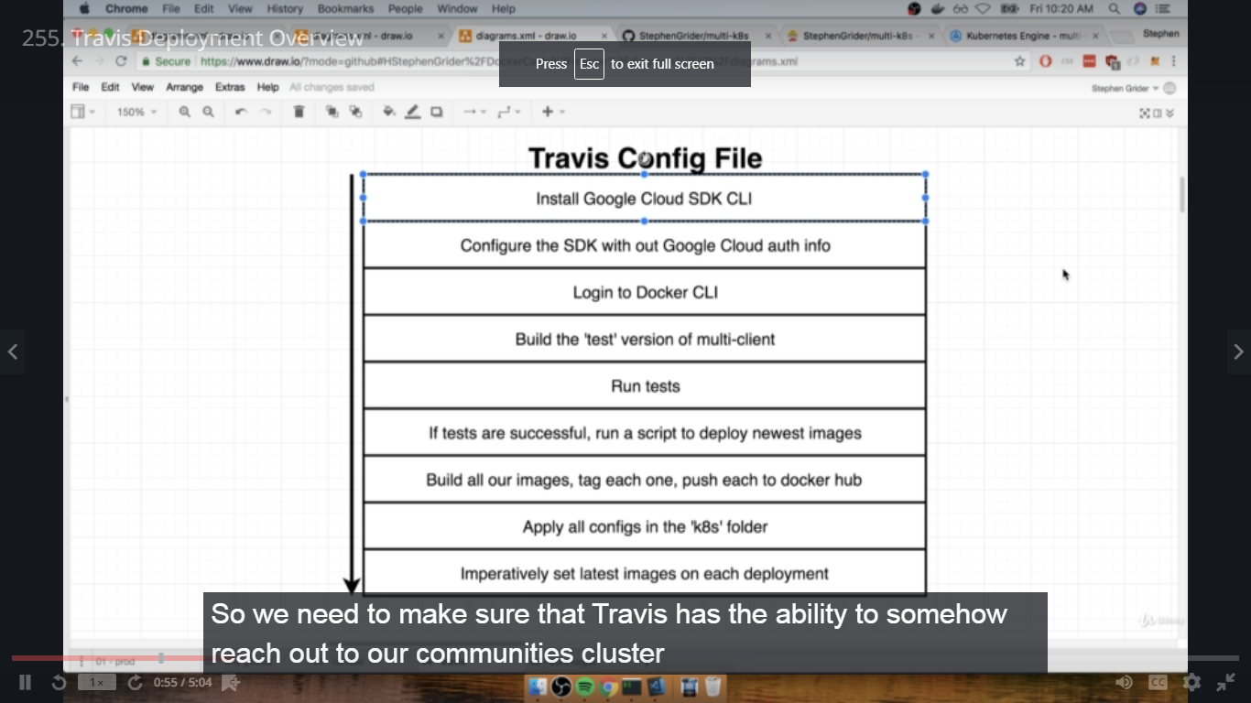

256. Installing the Google Cloud SDK

In complex dir, create .travis.yml file

sudo: required

services:

- docker

before_install:

-curl https://sdk.cloud.google.com | bash > /dev/null;

- source $HOME/google-cloud-sdk/path.bash.inc

- gcloud components update kubectl

- gcloud auth activate-service-account --key-file service-account.json

257. Generating a Service Account

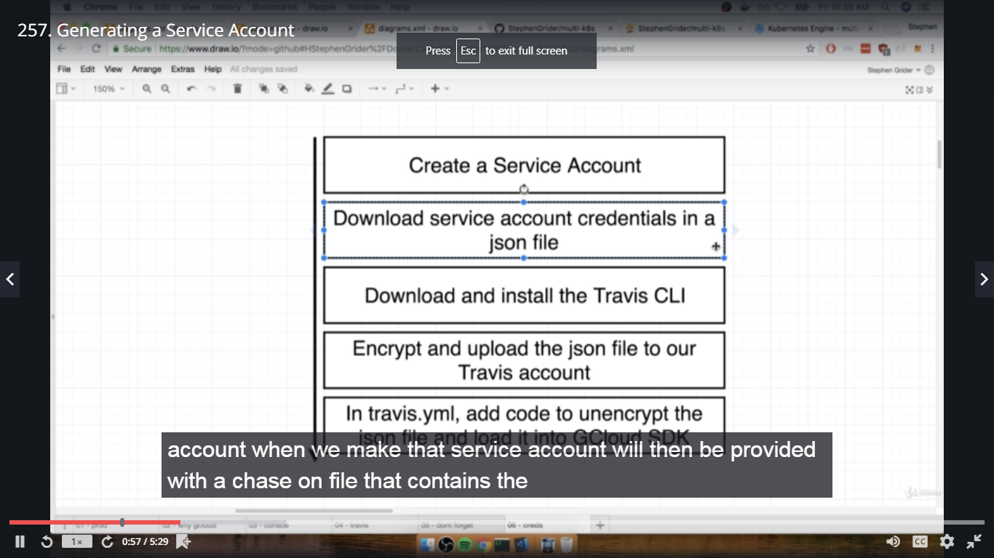

Go to Google Cloud Dashboard-->LHS Navigation menu-->IAM & admin-->Service Accounts-->Create Service Account-->Service account Name: travis-deployer-->Project role:KubernetesEngine admin-->key type: json file-->Save

258. Running Travis CLI in a Container

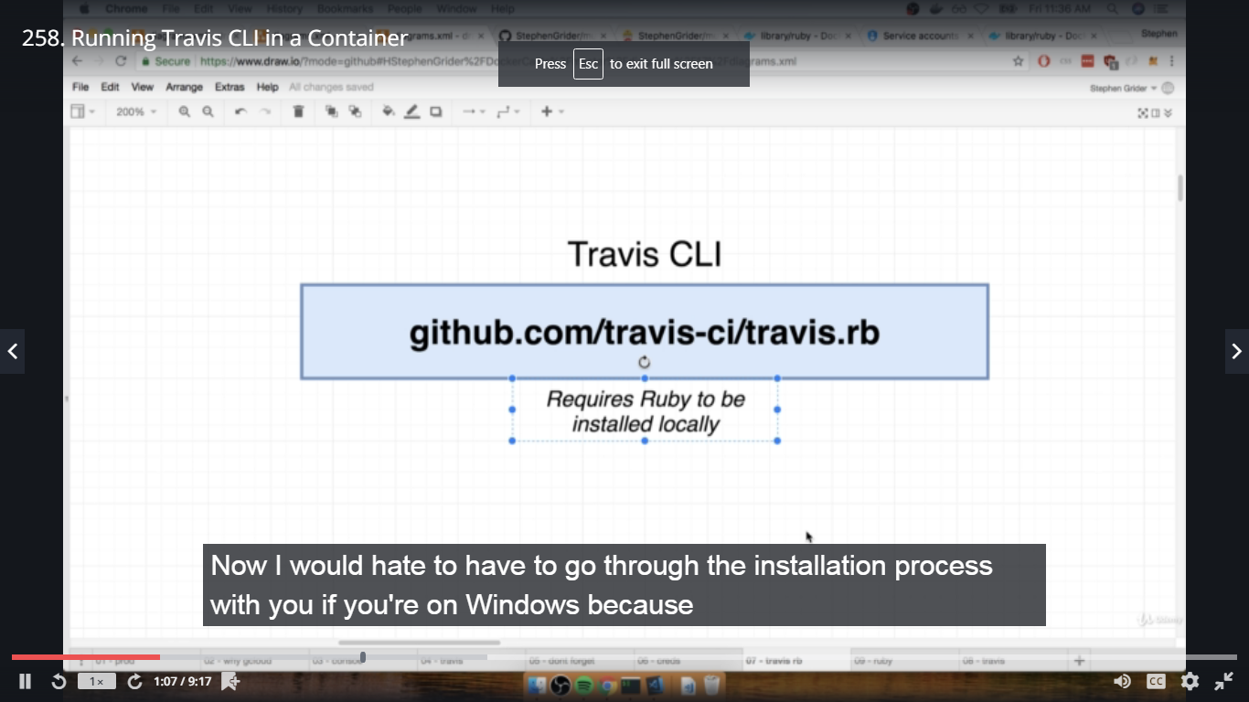

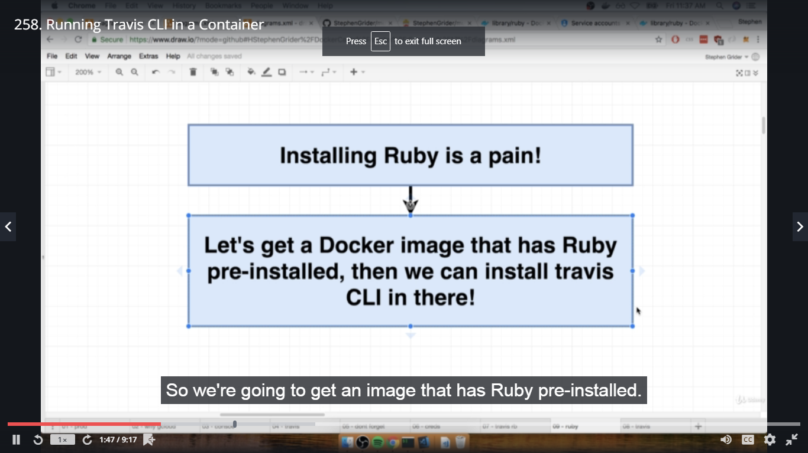

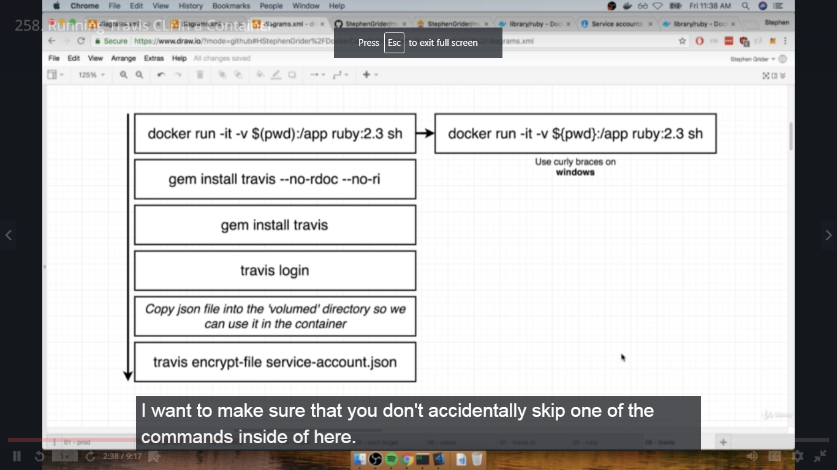

In terminal complex dir,

#docker run -it -v $(pwd):/app ruby:2.3 sh

#ls

#cd app

#ls

#gem install travis --no-rdoc --no-ri

#travis

259. Encrypting a Service Account File

In terminal complex dir in above sh,

#travis login

Username and Password of github login as we have sign in with github credentials

Copy json file from Downloads to complex dir and rename file as service-account.json

Now check in terminal,

sh

#ls

#travis encrypt-file service-account.json -r dockeruserid/name_of-repo(multi-k8s)

Copy the cmd and paste in .travis.yml file in complex dir,

before_install:

- openssl.....paste cmd

#ls ---- you will get service-account.json.enc file which we have to add in git repository

Delete the original service-account.json file in complex dir,

#ls

#exit

In terminal complex dir,

#ls

#git add .

#git commit -m "added encrypted service account file"

260. More Google Cloud CLI Config

Add in .travis.yml file in complex dir,

-gcloud config set project (paste id of the project from google cloud)

-gcloud config set compute/zone (paste location from google cloud cluster location)

-gcloud container clusters get-credentials multi-cluster(multi-cluster is name of cluster)

261. Fix For Failing Travis Builds

In the upcoming lecture we will be adding a script to our .travis.yml file. Similar to our previous projects that ran tests using Travis, we need to make sure the tests exit after running and don't cause our builds to fail.

Make sure to change this script:

script:

- docker run USERNAME/docker-react npm run test -- --coverage

To use the CI flag and remove coverage:

script:

- docker run -e CI=true USERNAME/docker-react npm run test

262. Running Tests with Travis

Add in .travis.yml file in complex dir,

- echo "$DOCKER_PASSWORD" | docker login -u "$DOCKER_USERNAME" --password-stdin

Go to travis-ci.org -->multi-k8s project--->Environment Variables--> Add

DOCKER_USERNAME: dockeruserid

DOCKER_PASSWORD: password ------>Add

Add in .travis.yml file in complex dir,

- docker build -t dockeruserid/react-test -f ./client/Dockerfile.dev ./client

script:

- docker run dockeruserid/react-test npm test -- --coverage

263. Custom Deployment Providers

Add in .travis.yml file in complex dir,

deploy:

provider: script

script: bash ./deploy.sh

on:

branch: master

264. Unique Deployment Images

Create deploy.sh in complex dir,

docker build -t dockeruserid/multi-client -f ./client/Dockerfile ./client

docker build -t dockeruserid/multi-server -f ./server/Dockerfile ./server

docker build -t dockeruserid/multi-worker-f ./worker/Dockerfile ./worker

docker push dockeruserid/multi-client

docker push dockeruserid/multi-server

docker push dockeruserid/multi-worker

kubectl apply -f k8s

kubectl set image deployments/server-deployment server=dockeruserid/multi-server

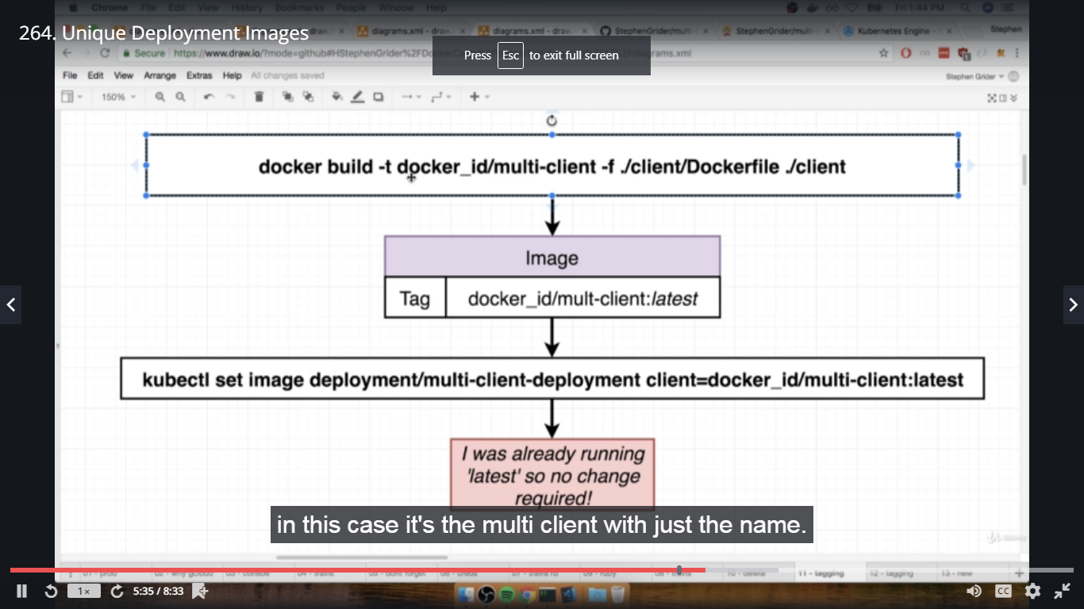

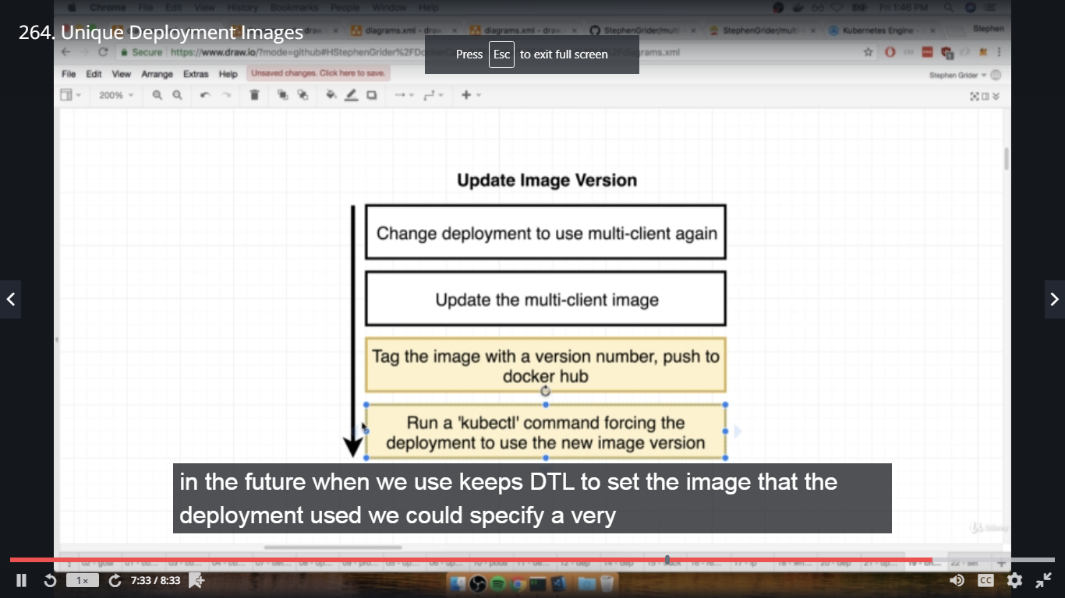

265. Unique Tags for Built Images

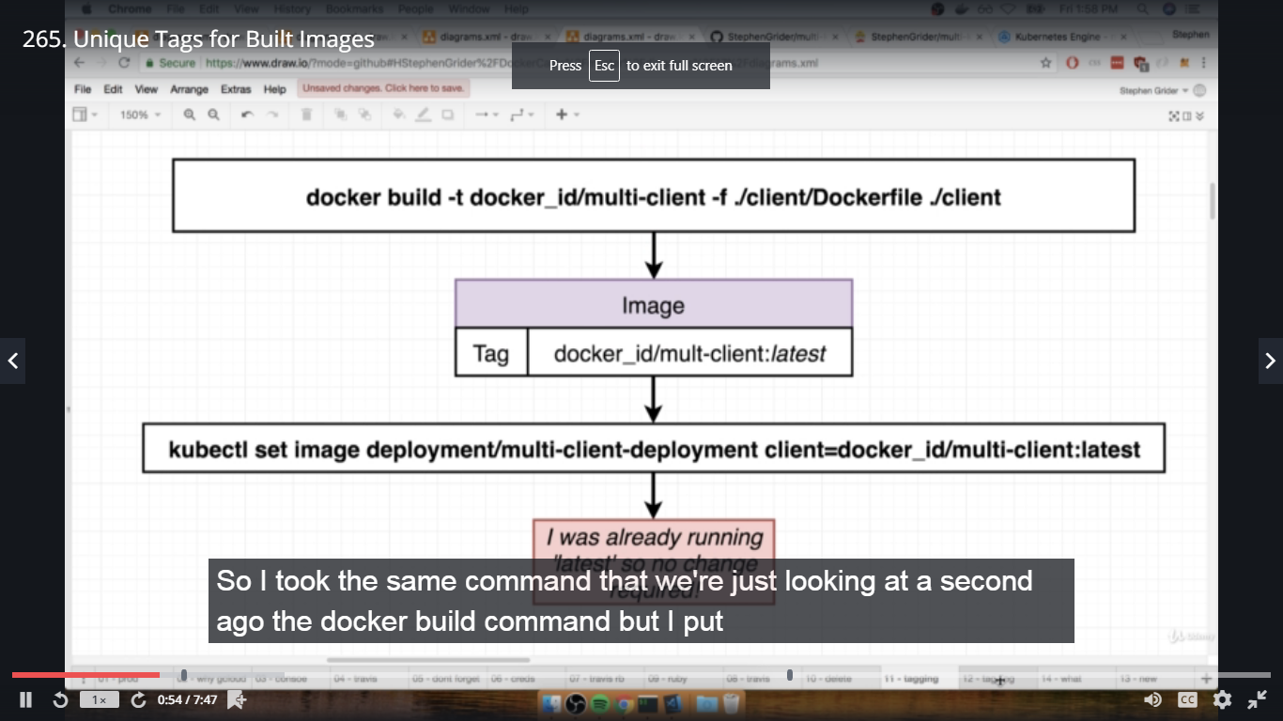

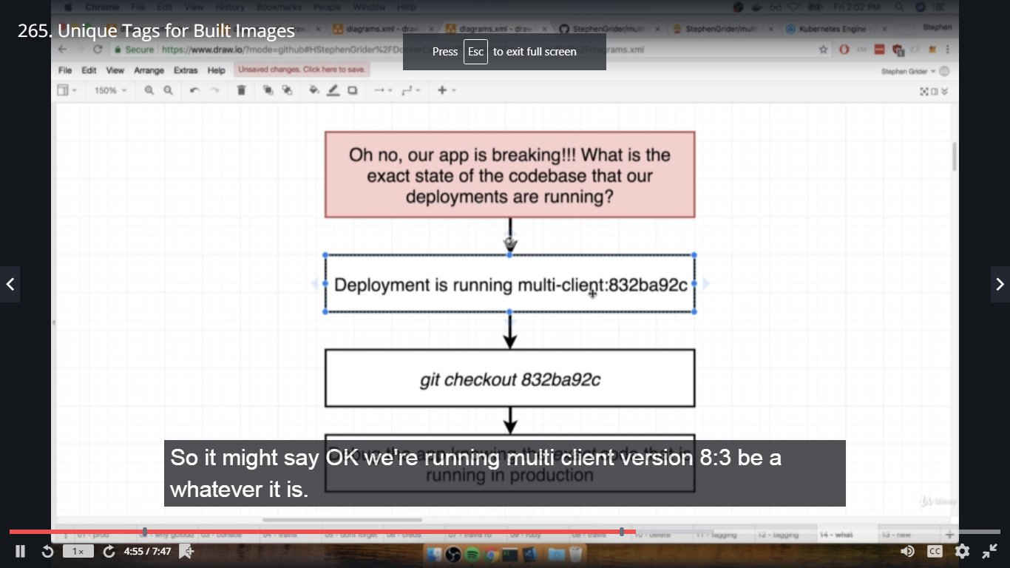

sha is a unique indentifying token,

In terminal complex dir,

#git rev-parse HEAD

#git log ---- sha is there for each commit

266. Updating the Deployment Script

Add env between services and before_install in .travis.yml file in complex dir,

env:

global:

- SHA=$(git rev-parse HEAD)

- CLOUDSDK_CORE_DISABLE_PROMPTS=1

Add tags to the build in deploy.sh file in complex dir,

docker build -t dockeruserid/multi-client:latest -t dockeruserid/multi-client:$SHA -f ./client/Dockerfile ./client

docker build -t dockeruserid/multi-server:latest -t dockeruserid/multi-server:$SHA -f ./server/Dockerfile ./server

docker build -t dockeruserid/multi-worker:latest -t -t dockeruserid/multi-worker:$SHA -f ./worker/Dockerfile ./worker

docker push dockeruserid/multi-client:latest

docker push dockeruserid/multi-server:latest

docker push dockeruserid/multi-worker:latest

docker push dockeruserid/multi-client:$SHA

docker push dockeruserid/multi-server:$SHA

docker push dockeruserid/multi-worker:$SHA

kubectl apply -f k8s

kubectl set image deployments/server-deployment server=dockeruserid/multi-server:$SHA

kubectl set image deployments/client-deployment client=dockeruserid/multi-client:$SHA

kubectl set image deployments/worker-deployment worker=dockeruserid/multi-worker:$SHA

267. Configuring the GCloud CLI on Cloud Console

In Google Cloud Dashboard, click on RHS Activate Cloud Shell,

In shell,

$ gcloud config set project (projectid from google cloud)

$ gcloud config set compute/zone (location of google cloud cluster)

$ gcloud container clusters get-credentials multi-cluster(name of cluster)

268. Creating a Secret on Google Cloud

In Google Cloud Shell,

$ kubectl get pods

$ kubectl create secret generic pgpassword --from-literal PGPASSWORD=mypgpassword123

Check secret created in Configuration tab.

269. Helm v3 Update

This note is if you wish to use the latest version of Helm, which is now v3. This is a major update, as it removes the use of Tiller.

1. Install Helm v3:

curl https://raw.githubusercontent.com/helm/helm/master/scripts/get-helm-3 > get_helm.sh

chmod 700 get_helm.sh

./get_helm.sh

2. Skip the commands run in the following lectures:

Helm Setup, Kubernetes Security with RBAC, Assigning Tiller a Service Account and Ingress-Nginx with Helm. You should still watch these lectures and they contain otherwise useful info.

3. Install Ingress-Nginx:

helm repo add stable https://kubernetes-charts.storage.googleapis.com/

helm install my-nginx stable/nginx-ingress --set rbac.create=true

270. Helm v2 Update

This note is for students who wish to continue using v2 of Helm with Tiller and follow along with the next few lectures.

In your Google Cloud console, instead of the install instructions provided in the Helm Setup lecture, run the following commands:

curl -LO https://git.io/get_helm.sh

chmod 700 get_helm.sh

./get_helm.sh

271. Helm Setup

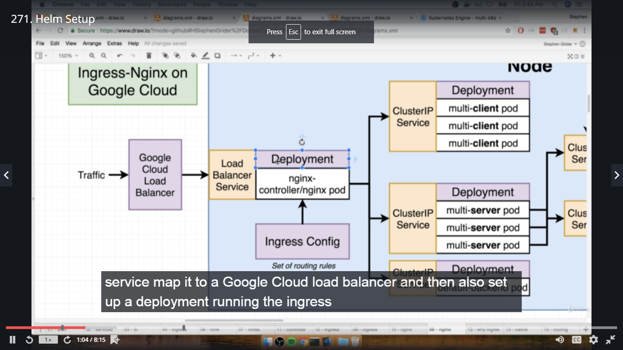

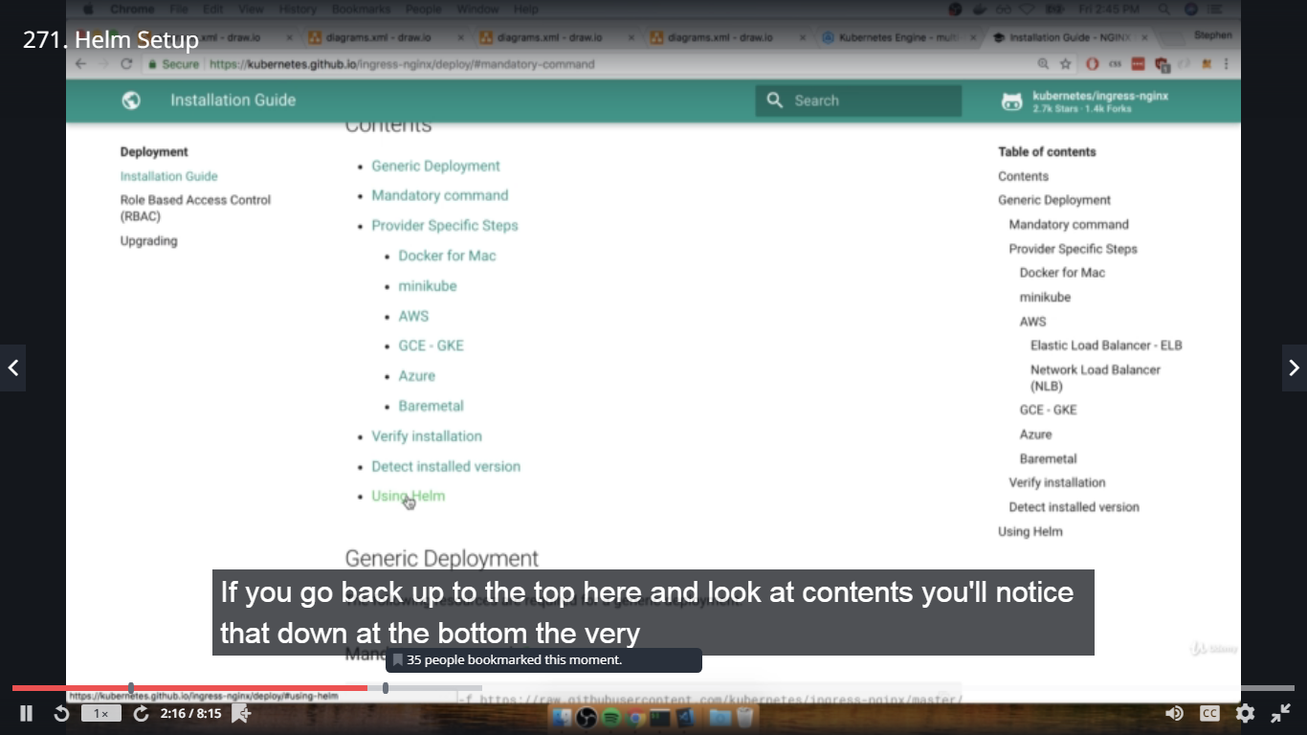

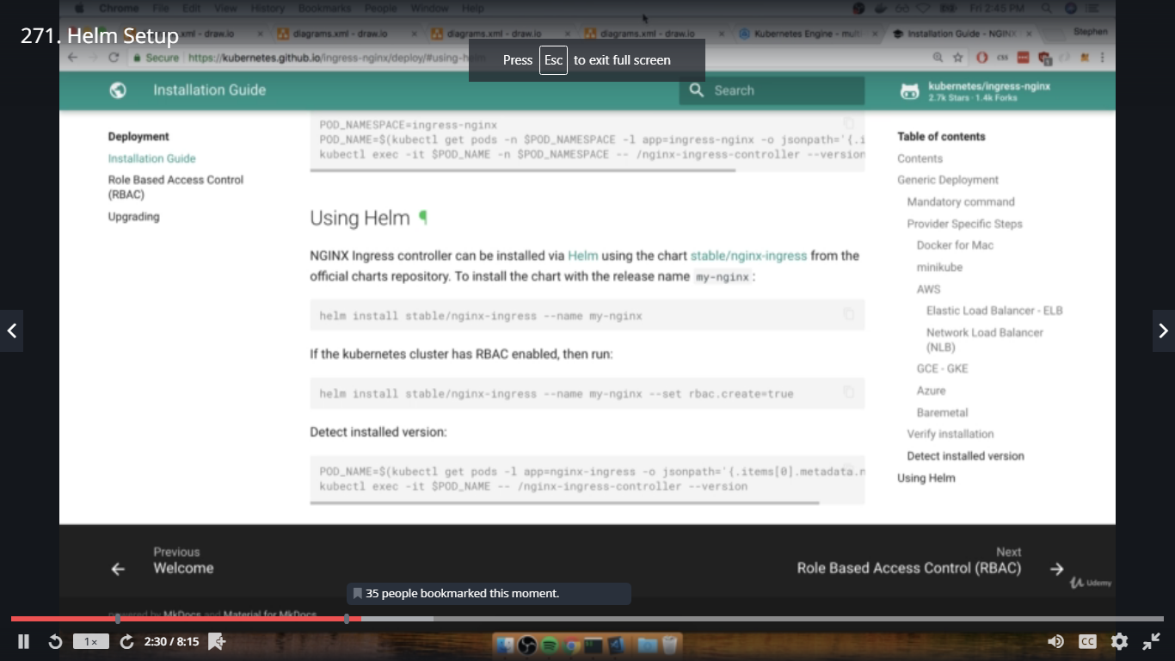

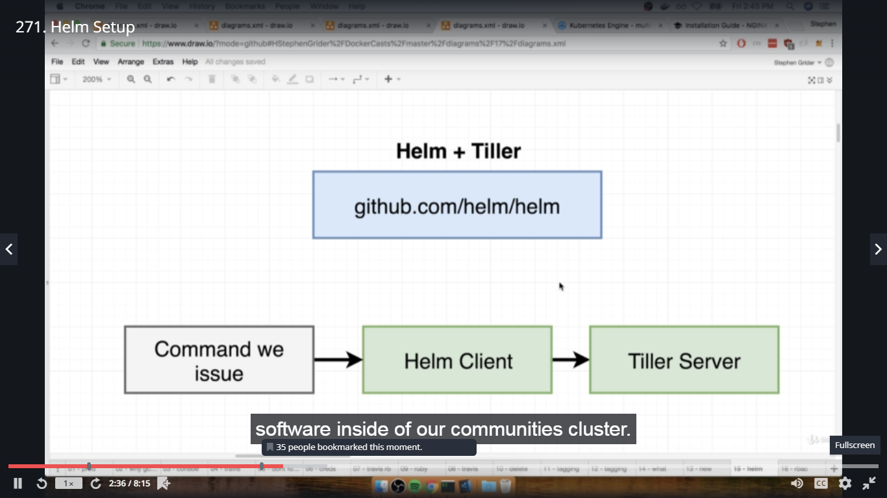

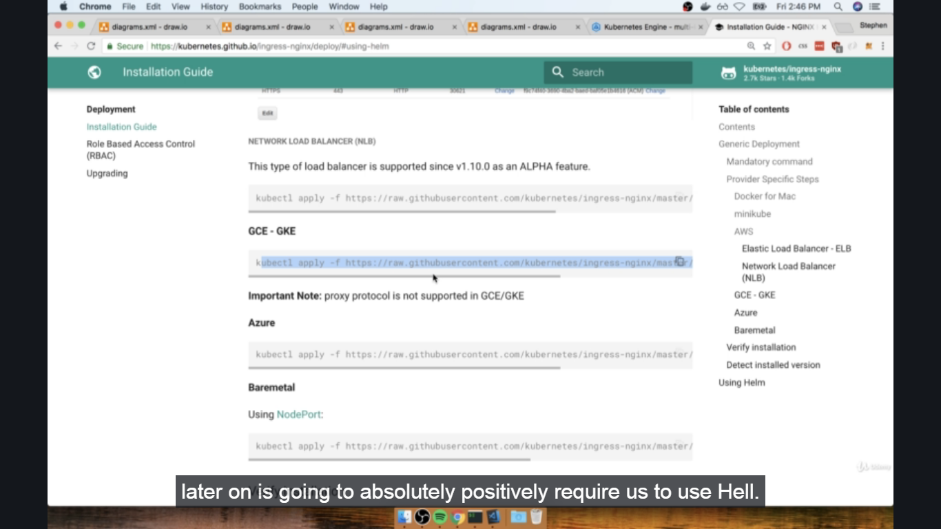

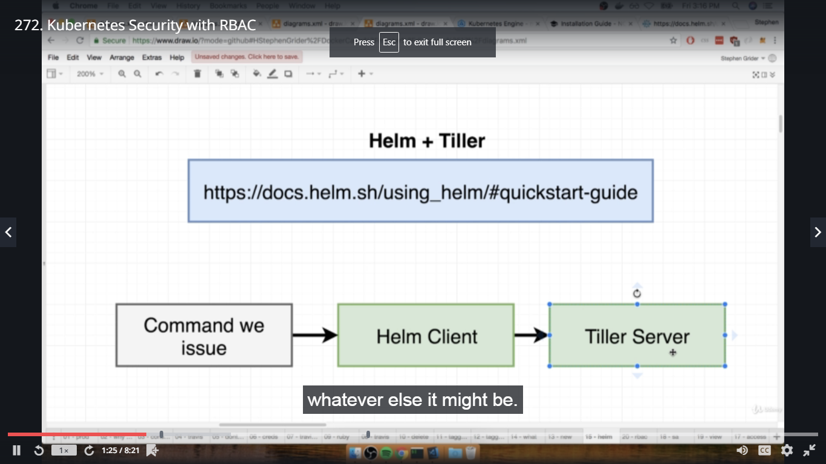

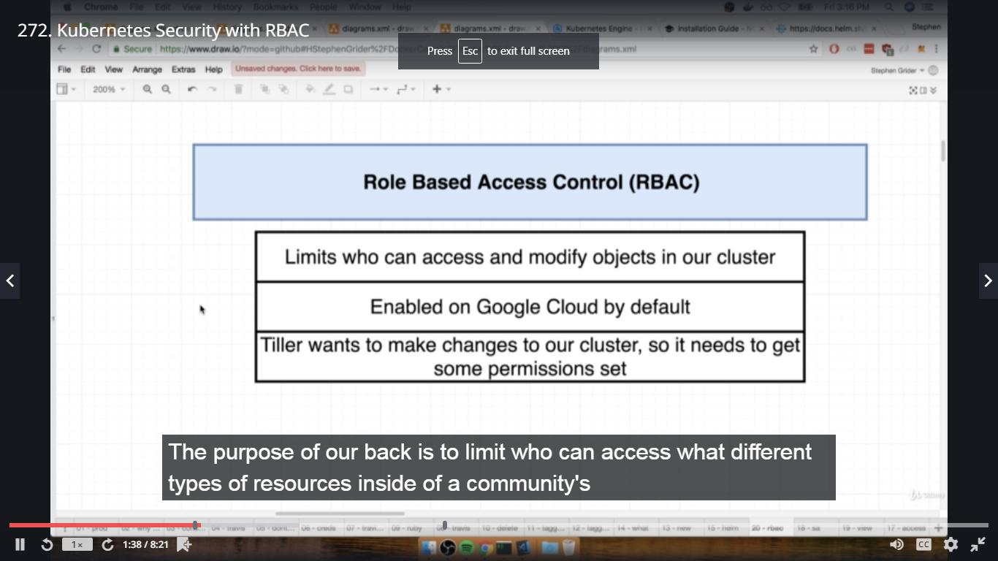

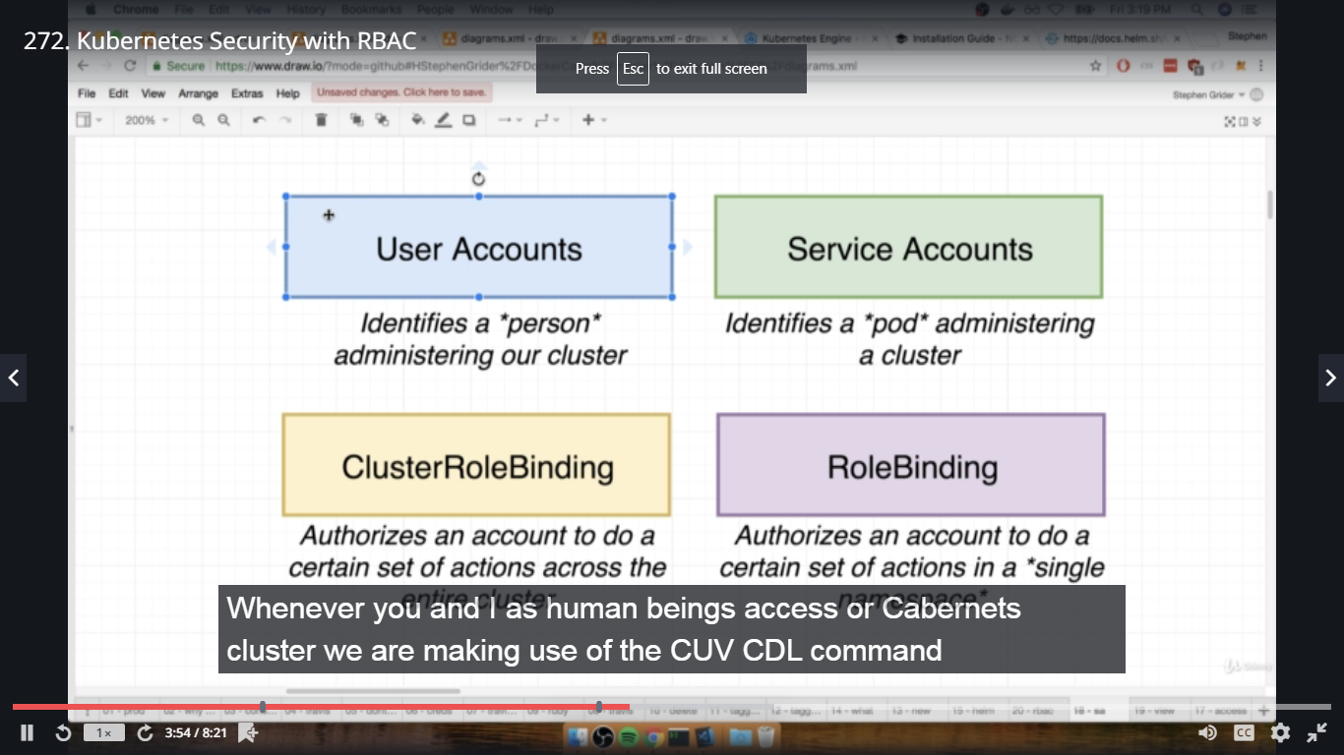

273. Assigning Tiller a Service Account

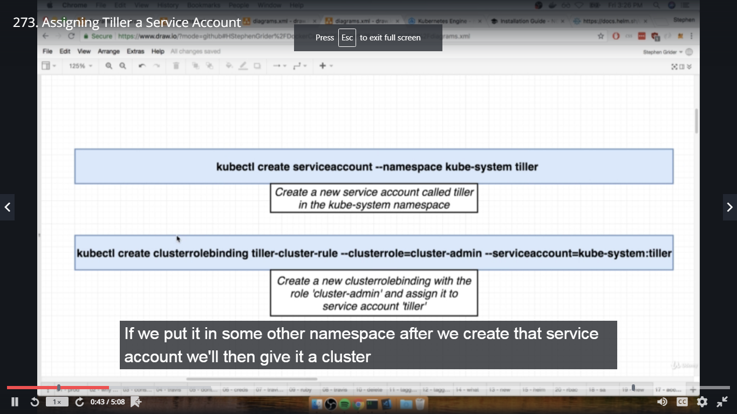

In google cloud shell,

$ kubectl create serviceaccount --namespace kube-system tiller

$ kubectl create clusterrolebinding tiller-cluster-rule --clusterrole=cluster-admin --serviceaccount=kube-system:tiller

$ helm init --service-account tiller --upgrade

With the helm installed, we can use it to install new services such as nginx ingress inside application

274. Ingress-Nginx with Helm ----- refer nginx ingress document

275. The Result of Ingress-Nginx

Go through options in google cloud dashboard. ----- Workloads, services, etc

Network services---->Load balancer details

276. Finally-Deployment!

In terminal complex dir,

#git status

#git add .

#git commit -m "added deployment scripts"

#git push origin master

Go to travis-ci.org---->multi-k8s project --->Check the build

277. Did I really type that?

Build got failed as error not interactive login, fixed the spelling mistake of DOCKER PASSWORD in .travis.yml file.

Again complete the git cmds and build is successful this time.

278. Verifying Deployment

See all deployments in Workloads of google cloud dashboard, services, Configuration, storage.........

Check fib calculator application in browser, https://IP from services

279. A Workflow for Changing in Prod

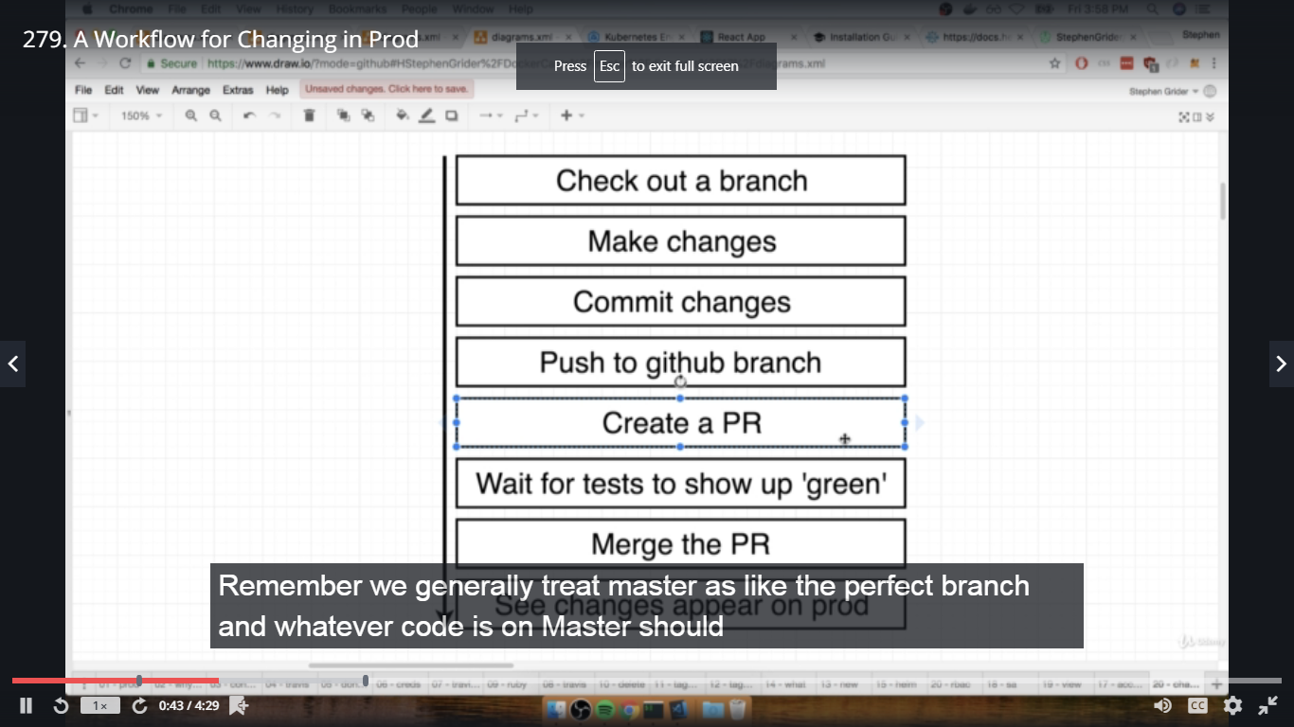

In terminal complex dir,

#git checkout -b devel

In complex-->client dir-->src-->App.js

Change <h1> Fib Calculator Version Kubernetes </h1>

In terminal complex dir and devel branch,

#git status

#git add .

#git commit -m "updated header"

#git push origin devel

Check in github.com--->dockeruserid/multi-k8s

you will see devel branch-->

Pull requests tab-->New pull request-->compare devel with basic master-->Create pull request

Updated header

Change the header in App.js

280. Merging a PR for Deployment

In github.com---->Merge Pull request----->Merge

Check in travis-ci.org also

281. That's It! What Next?

Check in brower ----https://IP (ip from services google cloud) ---- check new version Kubernetes

==============================================================================

**Section 17: HTTPS Setup with Kubernetes**

282. HTTPS Setup Overview

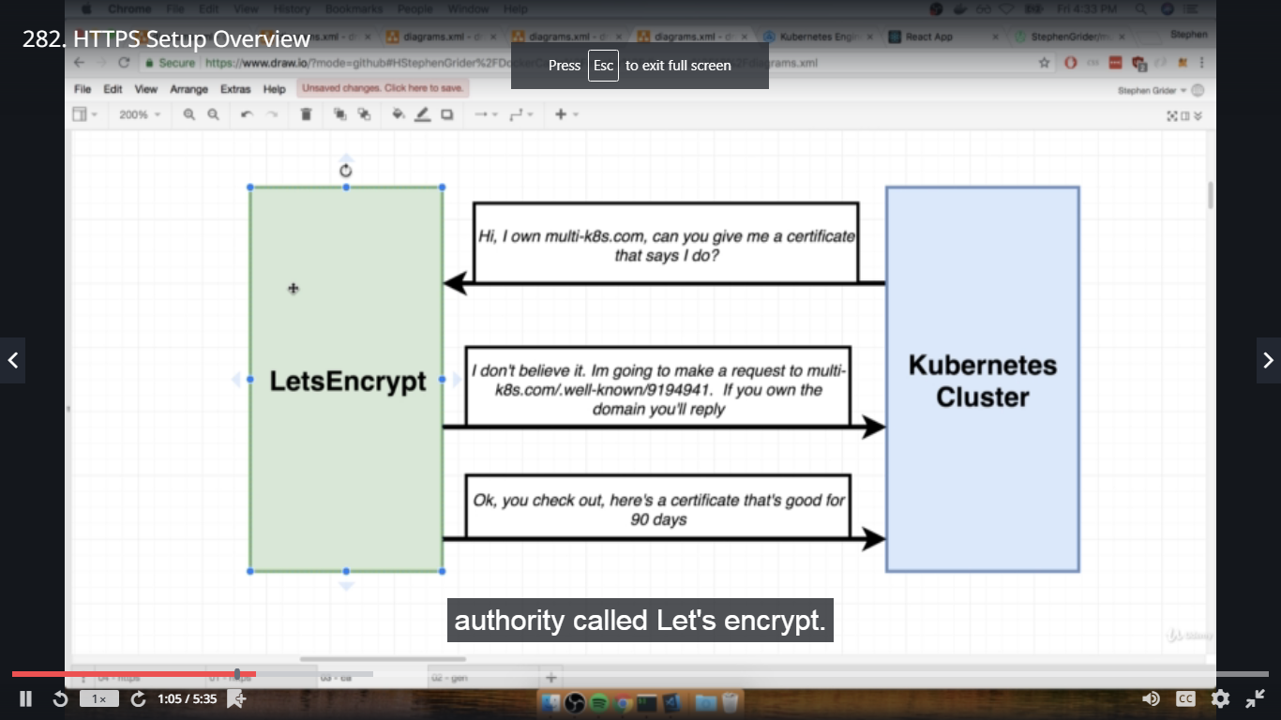

283. Domain Purchase

Go to domains.google.com--->Search Domain--->and once domain is selected,you will get domain name at domains.google.com

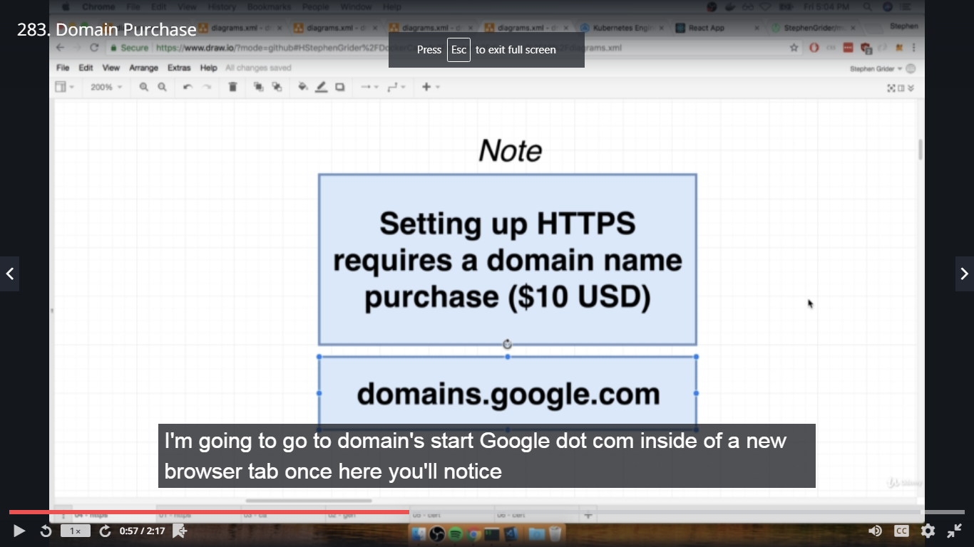

284. Domain Name Setup

Now in Google Cloud Platform--->Services--->here for this ip, domain name which we have purchased will be set up.

In domains.google.com--->k8s-multi.com domain--->Click on DNS-->Scroll down till Custom resource records

Name:@-->Type:A-->1H--->IP Address-->Add

Name:www-->Type:CNAME-->1H--->k8s-multi.com-->Add

285. Fix for Cert Manager Breaking Changes

In the upcoming lecture we will be installing the Cert Manager using Helm on Google Cloud. There have been some breaking changes introduced with v0.11.0 of Cert Manager, so we will need to do a few things differently.

Cert Manager Installation

The installations steps have changed, per the official docs here:

https://docs.cert-manager.io/en/latest/getting-started/install/kubernetes.html#steps

Instead of the installation instructions given at around 1:20 in the video, we will complete these steps by typing into our Cloud Shell:

1. Apply the yaml config file

kubectl apply --validate=false -f https://raw.githubusercontent.com/jetstack/cert-manager/release-0.11/deploy/manifests/00-crds.yaml

2. Create the namespace for cert-manager

kubectl create namespace cert-manager

3. Add the Jetstack Helm repository

helm repo add jetstack https://charts.jetstack.io

4. Update your local Helm chart repository cache

helm repo update

5. Install the cert-manager Helm chart:

Helm v2:

helm install \

--name cert-manager \

--namespace cert-manager \

--version v0.11.0 \

jetstack/cert-manager

Helm v3:

helm install \

cert-manager \

--namespace cert-manager \

--version v0.11.0 \

jetstack/cert-manager

issuer.yaml file

In the "Issuer Config File" lecture, the yaml file will need a few small changes per these docs:

https://docs.cert-manager.io/en/latest/tasks/issuers/setup-acme/index.html#creating-a-basic-acme-issuer

1. Make sure to update apiVersion as shown on line 1

2. Add the solvers property

apiVersion: cert-manager.io/v1alpha2

kind: ClusterIssuer

metadata:

name: letsencrypt-prod

spec:

acme:

server: https://acme-v02.api.letsencrypt.org/directory

email: "youremail@email.com"

privateKeySecretRef:

name: letsencrypt-prod

solvers:

- http01:

ingress:

class: nginx

certificate.yaml file

In the "Certificate Config File" lecture, only one minor change is required.

1. The only change needed in this file is to update the apiVersion on line 1:

apiVersion: cert-manager.io/v1alpha2

ingress-service.yaml file

In the "Ingress Config for HTTPS" lecture, we need to change one of the annotations.

certmanager.k8s.io/cluster-issuer: 'letsencrypt-prod'

change to:

cert-manager.io/cluster-issuer: "letsencrypt-prod"

286. Cert Manager Install

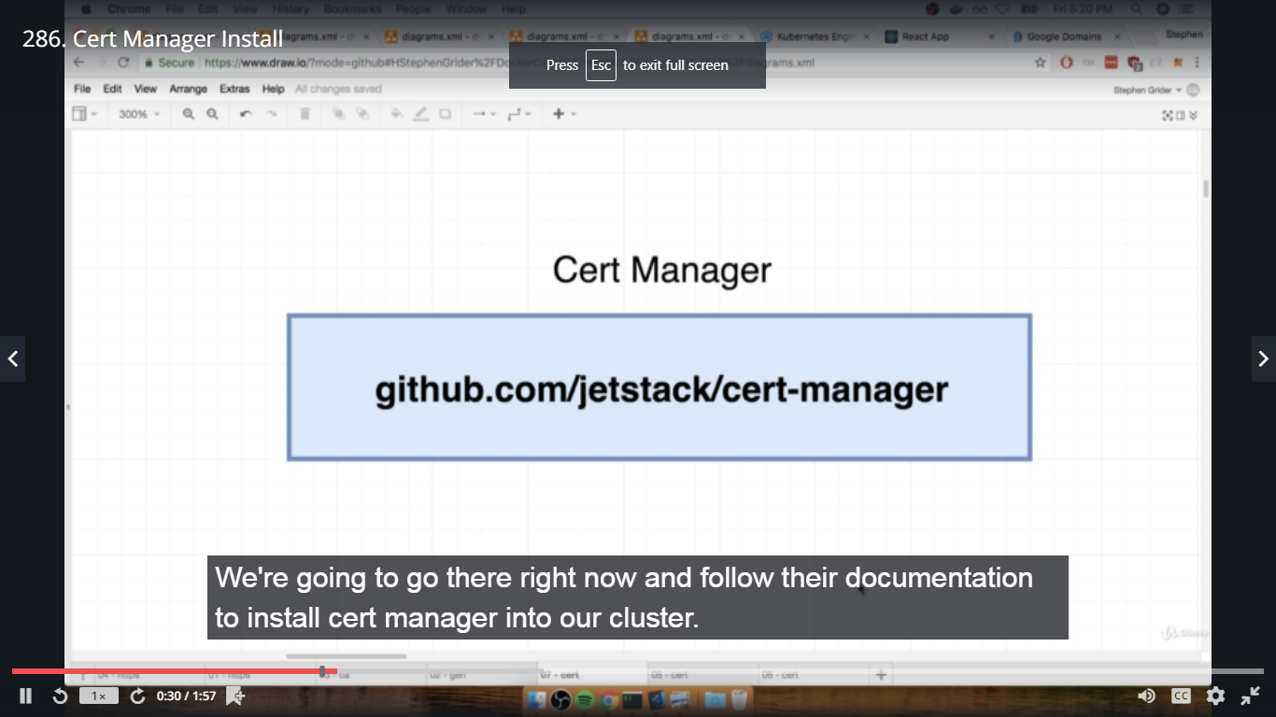

Go to github.com/jetstack/cert-manager---->Scroll down till Documentation-->Click on link--->Getting Started--->Installing cert-manager--->Copy cmd and paste in Google Cloud Dashboard shell.

287. How to Wire up Cert Manager

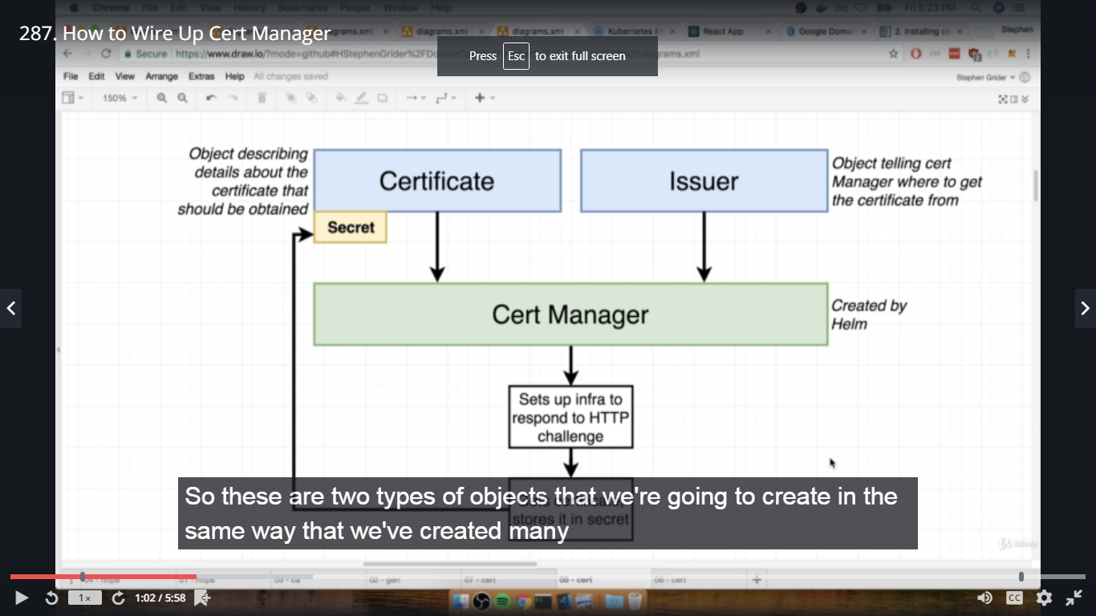

288. Issuer Config File

Create issuer.yaml file in k8s dir,

apiVersion: certmanager.k8s.io/v1alpha1

kind: ClusterIssuer

metadata:

name: letsencrypt-prod

spec:

acme:

server: https://acme-v02.api.letsencrypt.org/directory

email: 'ste.grider@gmail.com'

privateKeySecretRef:

name: letsencrypt-prod

http01: {}

289.Certificate Config File

Create certificate.yaml file in k8s dir,

apiVersion: certmanager.k8s.io/v1alpha1

kind: Certificate

metadata:

name: k8s-multi-com-tls

spec:

secretName: k8s-multi-com

issuerRef:

name: letsencrypt-prod

kind: ClusterIssuer

commonName: k8s-multi.com

dnsNames:

- k8s-multi.com

- www.k8s-multi.com

acme:

config:

- http01:

ingressClass: nginx

domains:

- k8s-multi.com

- www. k8s-multi.com

290. Deploying Changes

In terminal complex dir(devel branch),

#git checkout master

#git status

#git add .

#git commit -m "added certificate and issuer"

#git pull origin master

#git push origin master

Check in google cloud kubernetes dashboard--->Configuration-->Cluster created for certificate and issuer

291. Verifying the Certificat

In google cloud kubernetes dashboard--->Kubernetes shell--->

$ kubectl get certificates

$ kubectl describe certificates

$ kubectl get secrets

292. Ingress Config for HTTPS

Changes in ingress-service.yaml file in k8s dir,

under metadata-->annotations

certmanager.k8s.io/cluster-issuer: 'letsencrypt-prod'

nginx.ingress.kubernetes.io/ssl-redirect: 'true'

under spec:

tls:

- hosts:

- k8s-multi.com

- www.k8s-multi.com

secretName: k8s-multi.com

under rules:

- host: k8s-multi.com

Copy complete host part and paste below for

- host: www.k8s-multi.com

Again in terminal complex dir,

git add, commit and push

293. It Worked!

Check in browser--->https://k8s-multi.com and www.k8s-multi.com ---- fib calculator react app is working

294. Google Cloud Cleanup

Time for some cleanup! **If you want to close down the Kubernetes cluster running on Google Cloud, do the following.  Remember, you are paying for the running cluster!**

**Steps to clean up:**

**1) Click the project selector on the top left of the page**

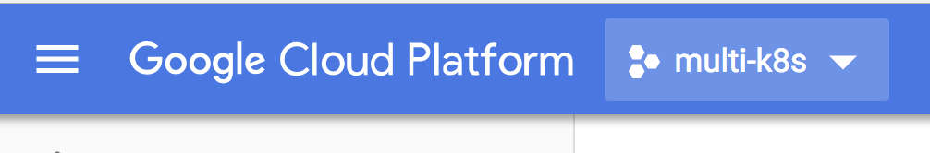

**2) Click the 'gear' icon on the top right**

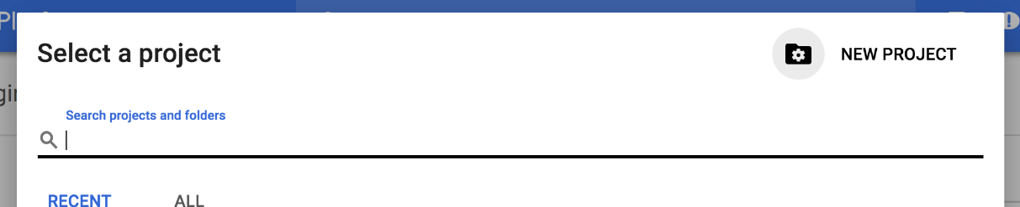

**3) Find your project in the list of projects that is presented, then click the three dots on the far right hand side**

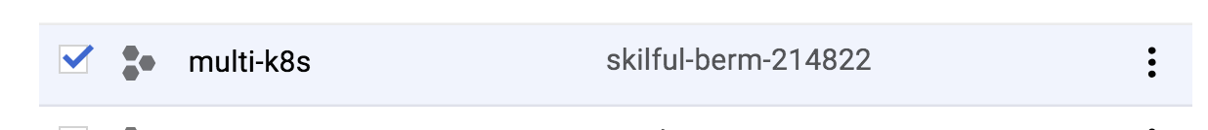

**4) Click 'Delete'**

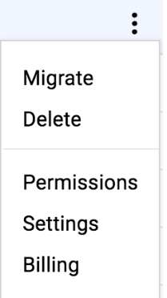

**5) Enter your project ID and click 'Shut Down'**

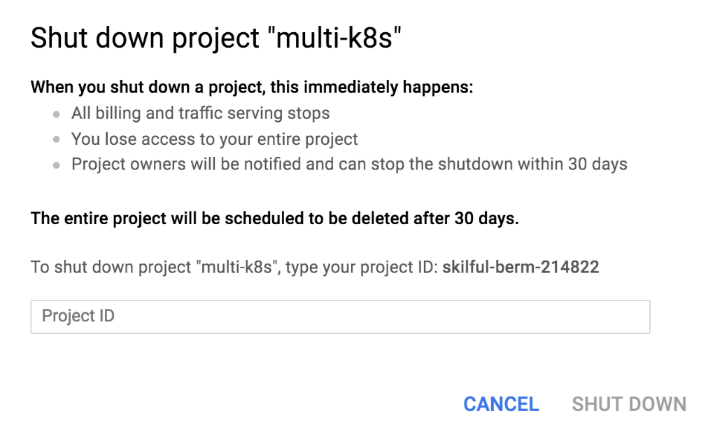

295. Local Environment Cleanup

You might want to also clean up some of the work you did on your local machine. Remember, we have a running Kubernetes cluster, and we have also built a ton of images.

**Stopping Minikube**

To stop Minikube, and the VM that it runs, run minikube stop .  You can bring your local cluster back online at any time by running minikube start

**Stopping Running Containers**

You might still have some containers running on your machine.  Try a docker ps .  You can then run docker stop <container_id> to clean up any running containers

**Clearing the Build Cache**

All the images that we built and ran during the course are cached on your local machine - they might be taking up to around 1GB of space.  You can clean these up by running docker system prune

**Section 18: Local Development with Skaffold**

296. Akward Local Development

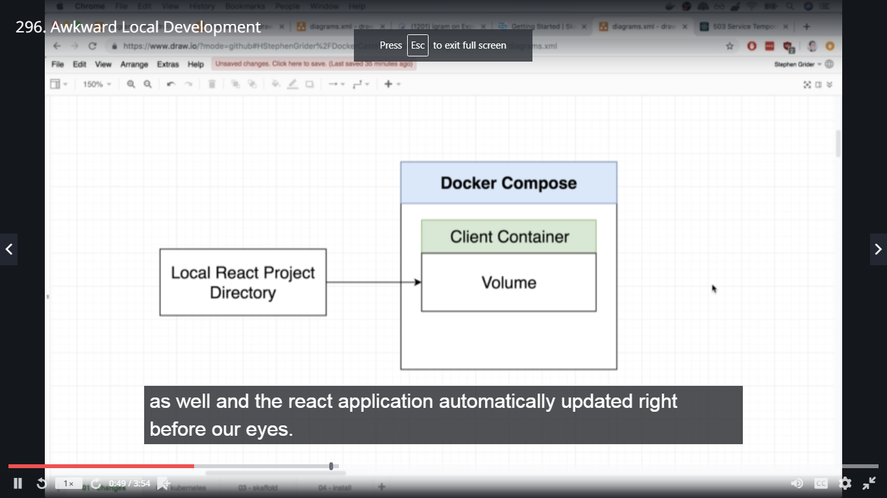

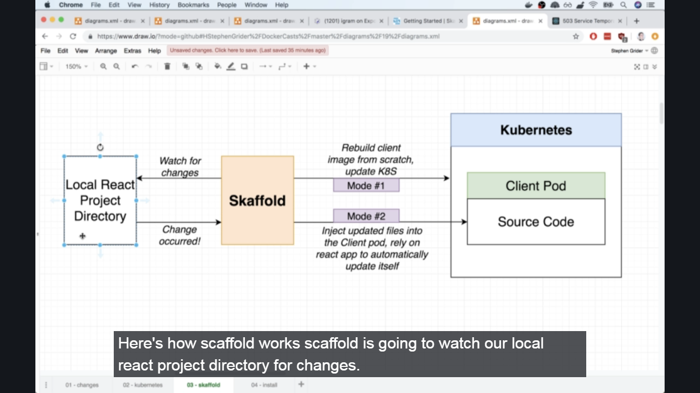

297. Installing Skaffold

